Academic School Year of 2024-2025

**ASSESSMENT S1: Creative Coder Case Study of Jared Tarbell**

**Submitted by:** Ong, Lynne Jessica T. (04-24-310)

**Submitted to:** Ms.Fakhra Batool

CC - Level 4 - Evening Class

**Date:** April 2, 2025

**Table of Contents**

List of Figures 3

Introduction 4

Review of Related Literature 6

I. The Community that Shaped Him 6

II. His Signatures and Styles 6

III. Applications/Technology Used 7

IV. Impact and Legacy 8

Image of Works (2023 – Present) 11

Conclusion 14

References 15

# **List of Figures**

Figure 1 Image taken from Reasons.to (2016) 4

Figure 2 levitated.net 2000-2004, arts done using Flash 7

Figure 3 Vesica Piscis: You, Me, We (2020) Processing Sketch 8

Figure 4 Substrate (2003) 9

Figure 5 Flower Composition (2023) 10

Figure 6 Ray Marching (2024) 11

Figure 7 Substrate Subcenter QBB (2024) by J. Tarbell 11

Figure 8 Node to Node (2023) 12

Figure 9 Node Garden Moment of Clarity (2023) 12

Figure 10 Circle Inversion (2023) 13

Figure 11 Mystic Rose (2023) 13

# **Introduction**

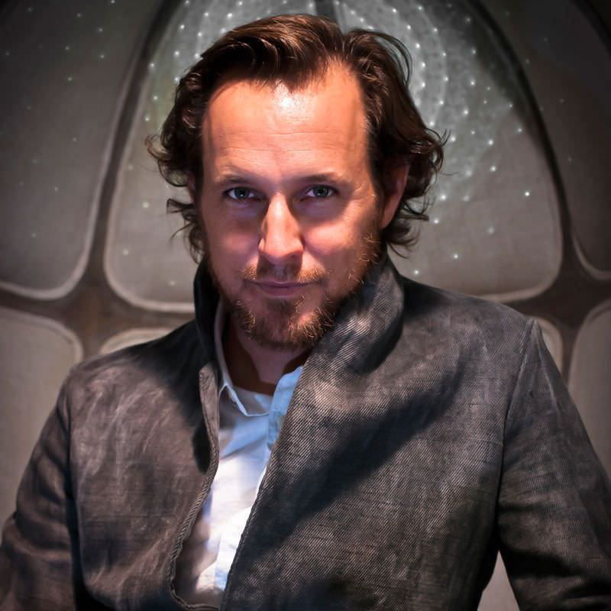

Figure 1 Image taken from Reasons.to (2016)

In a world where technology is continuously increasing and developing, art nowadays is not only drawn by hand but also improved with the usage of coding. Wherein creativity flows through the lists of syntax, functions, conditions, or overall codes. This is the world of Jared Tarbell, a generative artist and creative coder who pushes his art of algorithms to transcend the boundaries of art and technology itself. Through his work, Jared realized that art is a space that needs to be continuously studied to know which influences and what techniques would help his work the best, leading to successful digital art.

Jared Tarbell was born in 1973, and at the age of 14 he was introduced to computers (Reasons, 2015). His interest grew, leading to his successful career as a generative artist and computer programmer. He was also a co-founder of Etsy. As he studied, his interest in computers also increased. Tarbell used his experience as a computer science graduate in creating different types of art before officially calling them "art" because he viewed his art before as something that's more of an academic exercise (Right Click Save, 2024).

According to the interview conducted by Bailey (2020), Tarbell said that he wasn't aiming to be an artist because he aims to create video games. He stayed away from the idea of art because he didn't want to inspire or be asked about the "nature of the universe" since he wanted to contribute more with the use of games. Yet fate was already decided; he became an artist and a creative coder who is known for his generative arts. His work on the algorithm takes a day, and a couple of more days in creating the art using the app Processing; it will take days due to what he wanted to express or present and until he is satisfied with the result. As he started selling his work, he wrote his own shopping cart, which became a three-month struggle, yet he surpassed it (Bailey, 2020).

# **Review of Related Literature**

## **The Community that Shaped Him**

* 1. **His Mother**

Tarbell mentioned that he was encouraged by his mother to make art at home from a young age. His mother had an important role in giving him an overview about art, exposing him with an environment wherein he is freely to show his artistic side (Bailey, 2020). The influence of his mother became a bridge for a beginner to shape his core; without his mother, it is possible that he couldn't be the generative artist he is right now.

* 1. **Edward Tufte**

Aside from his mother, Edward Tufte was the one who opened the door to Tarbell's heart because Tufte breaks the design with visual rules of creating art using simple shapes (Bailey, 2020). Tufte helped Tarbell, inspiring him to explore the simple shapes to create something different and encouraging him to exceed his imagination.

## **His Signatures and Styles**

Jared Tarbell's style and signature in generative art have been inspired by the palette, art, and overall teachings of Edward Tufte. But he turned his simple art into a masterpiece that is pleasing to the eyes and inspiring to others.

* 1. **Algorithmic Simplicity**

Tarbell's works were limited on simplicity and algorithms; they were influenced by Edward Tufte because for him, drawing the elements matters more than the grid itself (Bailey, 2020).

* 1. **Nature-Inspired**

He is keen to observing everything that surrounds him, turning something that he had observed into a generative art. Just like the art "Substrate", he got the idea during his time in Santa Fe from a sticker that was in the window. The sunshine was pointed towards the sticker, reason for it to form cracks (Bailey, 2020).

According to the site of Kate Vass Galerie (2014), Tarbell has been coding for over 30 years. The art of Tarbell has been put into a digital exhibition and gallery wherein his arts are being visited and sold by the people all over the world.

Tarbell's way of showing his art to the world with simplicity and observation made him create his own name for the world to remember, not letting the boundaries of technology become a hindrance to his work.

## **Applications/Technology Used**

* 1. **Flash**

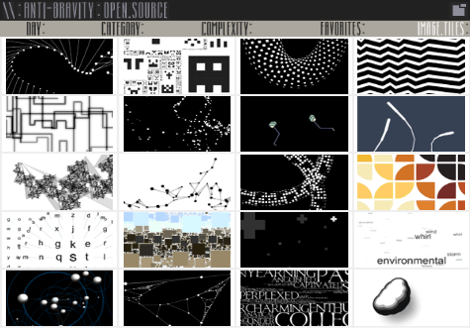According to the interview conducted by Kate Galerie (2024), Tarbell mentioned that he loved the application "Flash" because that is where he sketched his art before putting it on levitated.net in the early 2000s. It was the application that for him was a breakthrough of technology due its ability to share what you created on the browser "without any special hardware requirements or software to install" (Right Click Save, 2024).

Figure 2 levitated.net 2000-2004, arts done using Flash

* 1. 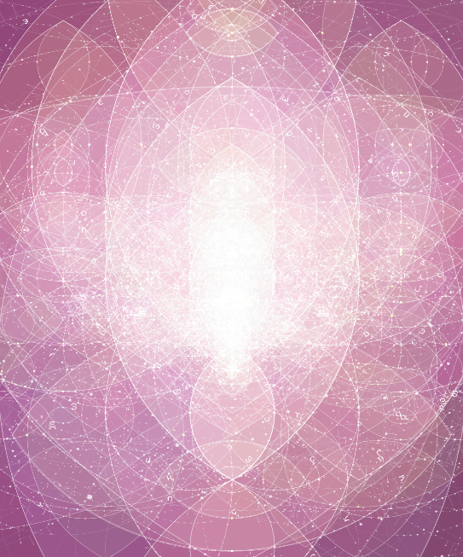**Processing**

Processing is the application that Tarbell uses in creating his digital arts from the year 2003 up to the present time. Processing is known for being an "open-source programming language and integrated development environment (IDE)" that is helpful not only for Tarbell but also for any aspiring artists, coders, and beginners (Lenovo, 2021). It became a suitable application for him because it was created by the co-founders Casey Reas, whom Tarbell has admired, and Ben Fry (Bailey, 2020). Moreover, the application helps the creator use algorithms at ease while also expressing themselves, building a bridge for a new art (Lenovo, 2021).

Figure 3 Vesica Piscis: You, Me, We (2020)   
Processing Sketch

## **Impact and Legacy**

Algorithm art is a form of rule systems that allows the creator to express their mind with the usage of technology to generate something that's beyond the imagination (Xu, 2020). Now generative art is the actual name that uses algorithmic codes; the artist itself explores while making decisions as to how the artist wants the art to look like (Christie's, 2023).

Tarbell used the inspiration that he got from Edward Tufte, which is by using simple patterns and designs, letting his imagination run wild to its fullest, transforming a simple algorithmic art into a stunning artwork.

1. **Etsy**

Before he became a full-time generative artist, he met Rob Kalin, who found his work at Complexification and decided to start Etsy with him in the year 2004 (Bailey, 2020). Etsy is an online platform where people earn, sell, and buy items.

Tarbell also stated in his interview with Bailey (2020) that during the time on Etsy, his passion for making art started fading since he was dedicated to his job as the co-founder of Etsy. Moreover, Tarbell figured that he wasn't suitable to be a business man since he is more passionate about computer-programmed related industry. (Beyond Tellerrand, 2018). It was only during the year 2011 that he managed to return in doing art. (Bailey, 2020).

1. 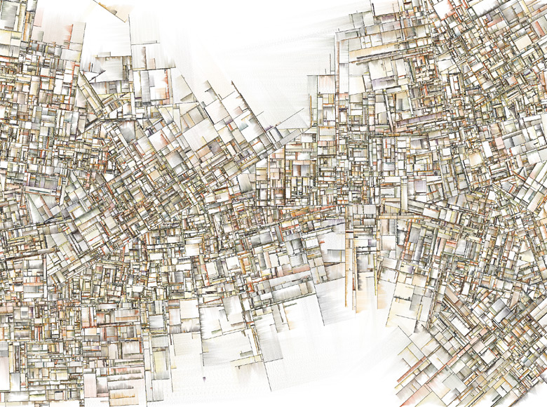**Outstanding Work**

One of Tarbell's famous works is "Substrate (2003)"; the art was created with only a line intersecting with another. The idea behind it is the cracks formed by the sticker on the window that was being shined by the sun (Bailey, 2020). This art that he created showed a side of Tarbell, a side where his everyday agenda became an observation to create another masterpiece based on what he had encountered in complexity.

Figure 4 Substrate (2003)

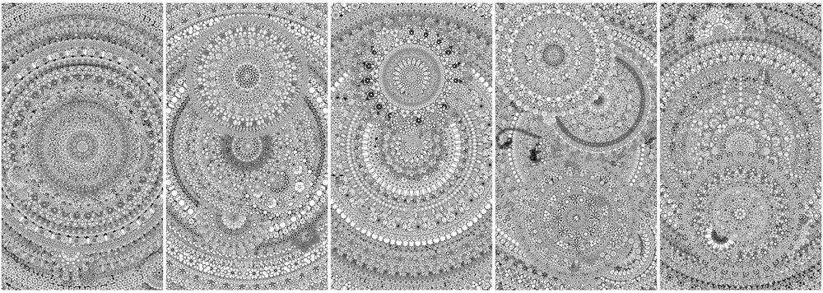Another one of his works is "Flower Composition (2023)." The art looks like a hand-drawn doodle, but it is actually radial symmetry. Tarbell loved the idea of symmetry; that's why he created this art in the colors of black and white (Right Click Save, 2024). It is a type of art that is commonly being drawn by artists and people who like doing things symmetrically; with this art, it would look like something that's worth coloring. But Tarbell decided to make it black and white because he views the world as something that's worth computing as it is his way of understanding them (Right Click Save, 2024).

Figure 5 Flower Composition (2023)

Tarbell is open to sharing his work through interviews as his way of helping the next generation of artists and coders to be inspired since he was also a beginner before the ideas started continuously flowing. His abilities and passion turned him into someone who helped pave the way for a different type of creativity to be expressed.

As generations come, Tarbell's legacy will continue to influence and motivate the next generation artists and coders.

# **Image of Works (2023 – Present)**

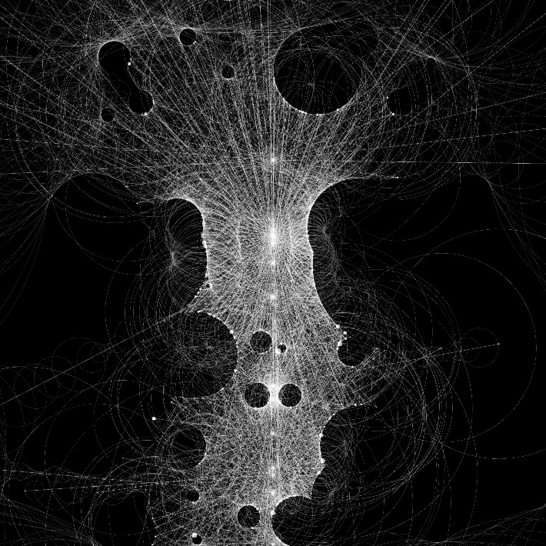These photos presented below are the recent works of Jared Tarbell, giving a simple yet unique generative art that he is making.

**Ray Marching (2024)** was created using the rays to explore the darkened spheres. It highlights the idea of "light moving through space" (Verse, 2024).

Figure 6 Ray Marching (2024)

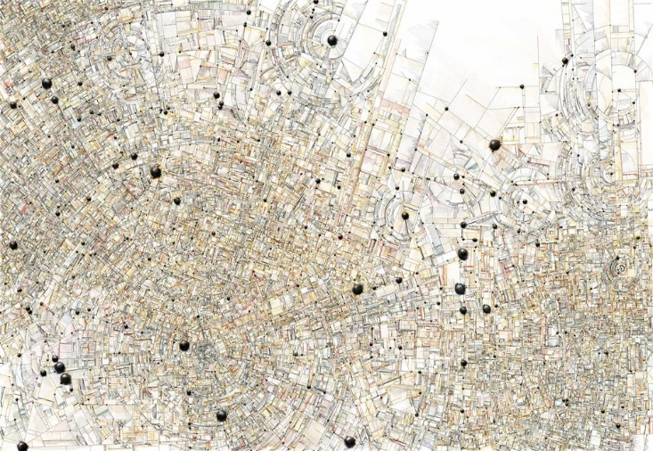**Substrate Subcenter QBB (2024)** is an algorithmic art that uses semantics (Bailey, 2020).

Figure 7 Substrate Subcenter QBB (2024) by J. Tarbell

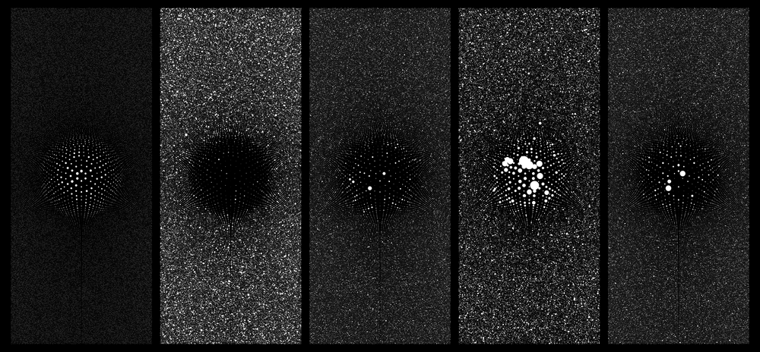**Node to Node (2023)** was created with sand strokes, giving it an "artistic quality" (Right Click Save, 2024).

Figure 8 Node to Node (2023)

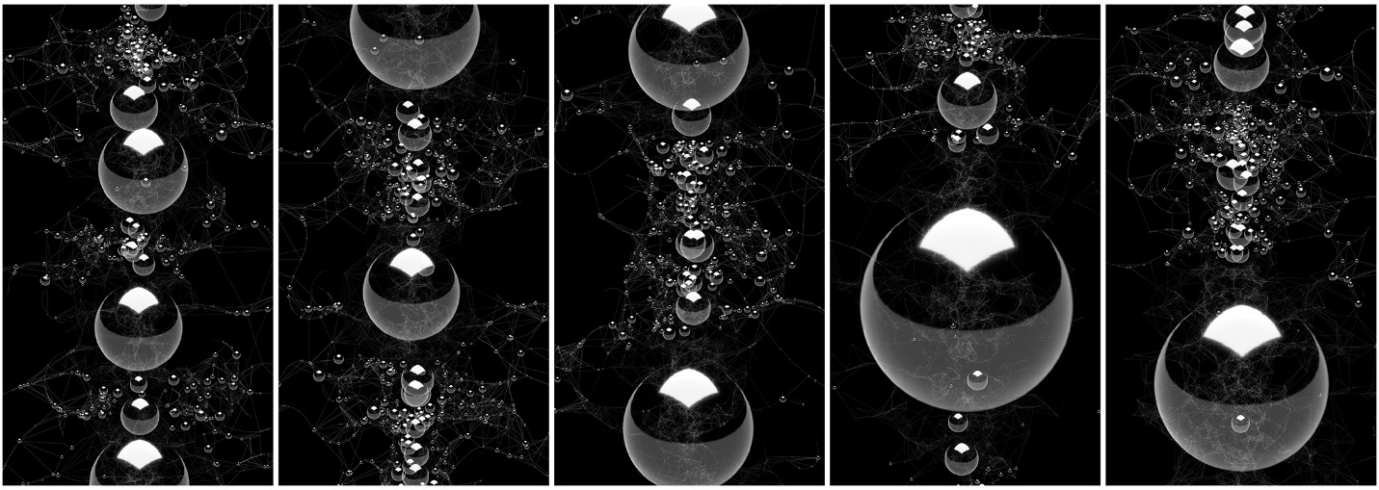

Figure 9 Node Garden Moment of Clarity (2023)

**Node Garden Moment of Clarity (2023)** was created using irregular curving lines; the sizes of the nodes defines the times a connection was formed (K011, n.d.).

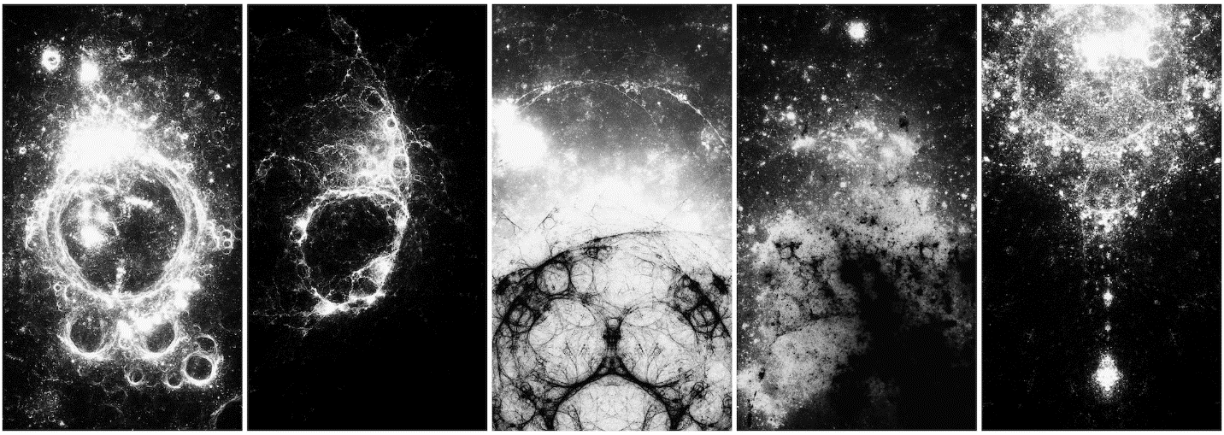**Circle Inversion (2023)** is an art that uses a circle and shifts its position using the circle inversion method, which was repeated a billion times (Kate Vass Galerie, n.d.).

Figure 10 Circle Inversion (2023)

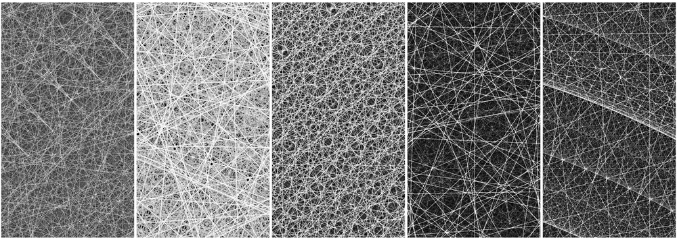

Figure 11 Mystic Rose (2023)

**Mystic Rose (2023)** is an art that connects one node to another, formatting complete graph lines (Le Random, 2023).

# **Conclusion**

Tarbell's journey as a generative artist and creative coder wasn't easy, he had several challenges yet he used every lesson that he learned in creating his art. Through his perseverance in pushing his limits and the boundaries of art and technology, Jared Tarbell has managed to make contributions and impact the world. His works are concrete proof of how one's life can turn around when art and code both meet, transforming something simple into something extraordinary.

Tarbell became one of the individuals who inspired countless people to continue exploring the possibilities of creative coding and combining it with art. The contribution that he is still continuously leaving us is that the evolution of creativity has no limits once it is built up with passion and belief in innovation.

# **References**

Bailey, J. (2020). *Interview With Generative Artist Jared Tarbell*. [online] Available at: <https://www.artnome.com/news/2020/8/24/interview-with-generative-artist-jared-tarbell>.

Beyond Tellerrand. (2018). Jared Tarbell was speaking at beyond tellerrand 2018 in Düsseldorf. [online] beyond tellerrand Events. Available at: <https://beyondtellerrand.com/events/dusseldorf-2018/speakers/jared-tarbell>

Christies. (2023). AI and generative art collecting guide. [online] Available at: <https://www.christies.com/en/stories/ai-and-generative-art-collecting-guide-998d865bd6a84538a27f640da23b368f>

Kate Vass Galerie. (2014). [online] Kate Vass Galerie. Available at: <https://www.katevassgalerie.com/jared-tarbell>.

Kate Vass Galerie. (n.d.). [online] Kate Vass Galerie. Available at: <https://www.katevassgalerie.com/print/p/jared-tarbell-circle-inversion>.

K011. (n.d.). K011> Specialized Art and Tech Studio. [online] Available at: <https://www.k011.com/jared-tarbell/tar/Node%20Garden%20Moment%20of%20Clarity%20%232/6>

Lenovo. (2021). What is Processing? | How Does it Work? | Lenovo US. [online] Available at: <https://www.lenovo.com/us/en/glossary/processing/?orgRef=https%253A%252F%252Fwww.google.com%252F&srsltid=AfmBOoohmIS-x9h_2lLxNQbntmJWEHK_YGoBNFppaL_03RnchRx8OG6l>.

Le Random. (2023). Mystic Rose #1 by Jared Tarbell - Collection - Le Random. [online] Available at: <https://www.lerandom.art/collection/mystic-rose-1>

Reasons to: (2016). Reasons.to 2019. [online] Available at: <https://reasons.to/2016/brighton/speakers/jared-tarbell>

Right Click Save. (2024). *The Interview | Jared S. Tarbell*. [online] Available at: <https://www.rightclicksave.com/article/the-interview-jared-s-tarbell-generative-art-etsy>.

Verse. (2024). Jared S Tarbell Under Cosmic Influence: Channeling Art’s Liquidity into the Moon’s Orbit | Verse. [online] Available at: <https://verse.works/journal/ray-marching-moon-full-new>

Xu, C. (2020). Algorithmic Art: Beyond the Artist – USC Viterbi School of Engineering. [online] Available at: <https://illumin.usc.edu/algorithmic-art-beyond-the-artist/>